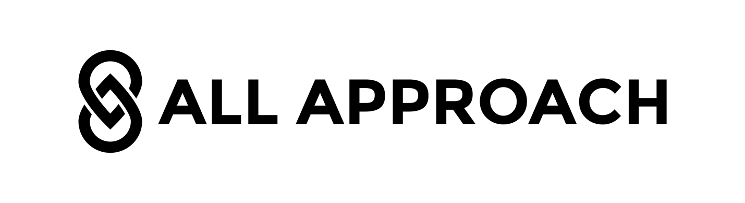
Client Onboarding Document – Logo Design

Welcome aboard! We are excited to get started. So that we can kick this off on the right foot, please fill out as much as possible below to the best of your ability.

What is your Business or Service name to incorporate into the logo?

Do you have a slogan you want to use?

What is your target audience? (Demographics that you are targeting)

Who are your competitors? (Name some competitors and/or write their websites)

What are the values you want to convey with your logo?

Application: (Where will your logo will be applied?) Highlight all that apply
  - Website
  - banner ads
  - email marketing
  - Print (Business cards)
  - letterhead
  - mailers)
  - Clothing
  - hats
  - embroidery
  - Promotional Items (pens, Mugs)
  - mugs
  - USB flash drives
  - Large Format (Signs)
  - marquis
  - billboards
  - car-wraps

Logo Style: (Which of the following logo styles below do you like the most? Feel free to select multiple or let us decide.)

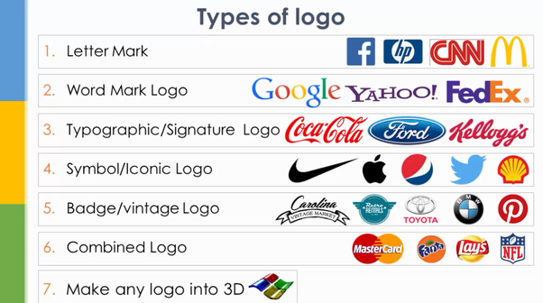

Constraints: (Specific colors or shapes, initials, uppercase, lowercase, etc.)

Restrictions: (Any fonts or colors restrictions?)

Additional Information: (Say what you want, any idea or request that comes to your mind regarding your logo design project)

Let’s rock it!!!

